**Array :**

**Introduction :** Need of array: If I want one integer variable, I will declare it as int x=10; suppose if I want to declare 2 integer values: int x=10; int y=20; if I want to have 3 integer values, I will declare 3 integer values. If I want to have 10,000 integer values. It will be worst programming practice to declare 10,000 integer variables. So if want to represent huge number of values using one/ single variable, we use array.

Definition : An array is an indexed collection of fixed number of homogenous data elements.

**Array declaration :**

**Array Creation :**

**Array Initialization :**

**Array declaration, Creation and Initialization in single line :**

**2D Arrays:**

**Array element assignments :**

**Array variable assignments :**

**\*\*\*\*\*\*\*\*\*\***

**Array Declaration :** int []x; int x[]; > Array declaration. We can’t specify size at declaration.

**Array Creation :** x= new int [3];

**Array Initialization :** a[0]=10; a[1]=20; a[2]=30;

**Array declaration, Creation and Initialization in single line :**

int [] a={10,20,30};

**We can also create array as** : int a[]=new int[5];

**Array can be of different types like int, char, string etc. :**

char[] C = { 'a', 'r', 't' };

String[] Str = {"AAA", "BBB"};

**Examples is in eclipse**

**2D Array :**

int[][] a = new int[3][3]; i.e. int[row][column]

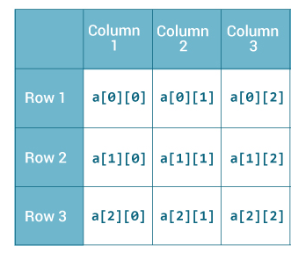

**Java array** is an object the contains elements of similar data type. It is a data structure where we store similar elements. Also, array is a collection of variables of the same data type.

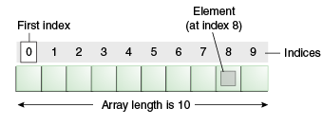

Declare array :

Int[] a; **OR** int a[]; 🡪 Declare array

a= new int [3]; 🡪 Create array

a[0]=10; 🡪 Initialize array

a[1]=20;

a[2]=30;

Can be done in 1 line as : 🡪 int [] a={10,20,30};

Array can be of different types like int, char, string etc.

char[] C = { 'a', 'r', 't' };

String[] Str = {"AAA", "BBB"};

**Multidimensional Array in java :**

1. **int**[][] arr=**new** **int**[3][3];//3 row and 3 column
2. arr[0][0]=1;
3. arr[0][1]=2;
4. arr[0][2]=3;
5. arr[1][0]=4;
6. arr[1][1]=5;
7. arr[1][2]=6;
8. arr[2][0]=7;
9. arr[2][1]=8;
10. arr[2][2]=9;